CENTRAL JERSEY CAT FANCIERS
Presents an Allbreed & Household Pet Cat Show
in conjunction with the Greater Philadelphia Pet Expo

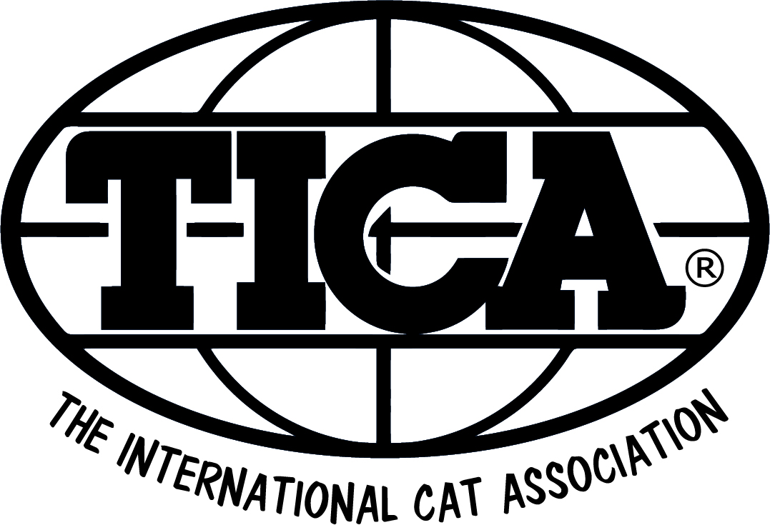
Greater Philadelphia
Expo Center
January 11-13, 2019
Oaks, PA
3-Day 20 RING SHOW – 125 Cats
JUDGES
 |  | Saturday AM |  | Sunday AM
 |  | Robin Higgins | AB | Lindajean Grillo | AB
 |  | Fate Mays | AB | Edith-Mary Smith | AB
 |  | Vicki Jo Harrison | AB | Alex Marinets | AB
 |  | Toni Jones | AB | Susanna Shon | SP
Friday PM |  | Saturday PM |  | Sunday PM
Vickie Fisher | AB | Lindajean Grillo | SP | Edith-Mary Smith | AB
Brenda Russo | AB | Connie Webb | AB | Vicki Jo Harrison | AB
Nikki Crandall-Seibert | AB | Alex Marinets | AB | Christina Baumer | SP
Fate Mays | SP | Toni Jones | AB | Susanna Shon | SP
Show Hall
Greater Philadelphia Expo Center
100 Station Avenue
Phoenixville, PA 19460
ENTRY CLERK: Cheryl Leigh Chamberlin
1512 Berkley Pl, Willow Grove, PA 19090
215-738-3767
entryclerk@ticama.org
Enter Online at http://ticama.org/cj
SHOW MANAGER: SUSAN ADLER 570-807-0406

Show Hall: The Show Hall is the Greater Philadelphia Expo Center, 100 Station Avenue, Oaks, PA 19460 (use Phoenxville for GPS). Phone (484) 754-EXPO
Fly into Philadelphia International Airport (PHL). Directions will be included with your confirmation.
Show Hotels Hilton Garden Inn Valley Forge/Oaks, 500 Cresson Blvd, Phoenixville, PA 19460. Phone 610-650-0880. Room rate $104/king or $114/2 doubles. There is a $50 REFUNDABLE pet deposit. Room block expires December 12, 2017. Group name is PET EXPO.
Hampton Inn & Suites Valley Forge/Oaks, 100 Cresson Blvd, Phoenixville, PA 19460. Phone 610 676 0900. Room Rate $104. There is a $50 REFUNDABLE pet deposit. Room block expires December 12, 2017. Group name is PET EXPO.
Homewood Suites, 61 Shannondell Blvd, Audubon, PA 19403. Phone 610-539-7300. Room rate $119. There is a $50 REFUNDABLE pet deposit. Room block expires December 21, 2017. Group name is PET EXPO.
Check-In and Show Hours: Check-in will be 8:00 to 9:00 a.m. on Saturday; late arrivals must check in with the Master Clerk and each Ring Clerk to ensure that their entries are marked present. Show hours both days are from 9:30 a.m. to 5:30 p.m. No cat may leave the show hall before the advertised show hours without permission from show management.
Show Services: The club will provide cages and litter. Please bring your own litter pans, cat food, cat food and water dishes, and cage curtains. Back, tops and sides of cages must be covered. Cages are approximately 22” x 22” x 23” - single; 22” x 22” x 45” – double. Each entry is provided with a single cage. A limited number of doubles will be available at an extra fee. Cats MAY NOT be left in the show hall overnight. No vending of any kind is allowed from the benching area. People food will be available from the hotel services.
Catalog Advertising: Black & white, camera-ready copy must be provided by 1/9/2018. Prices are listed on the summary sheet.
Show Rules: By entering, all exhibitors agree to abide by all TICA show rules, and the decisions of the Judges and Show Committee. Show rules are available from TICA, P.O. Box 2684, Harlingen, Texas 78551. Telephone: 956/428-8046.
Entries: An official entry form or facsimile must be used for each entry, and a completed Summary sheet with full payment must accompany the entry. The Entry Clerk will call collect if there are any significant questions about your entry.
Registration: To compete, cats (except ANB, PNB and NT classes) do not have to be registered with TICA. All cats in Preliminary and Advanced New Breed, and New Traits classes, must be registered. No points won may be claimed without TICA Registration. To register your cats(s) call the TICA Executive Office at 956/428-8046.
Household Pets: All HHP adults must be altered. Proof of spay/neuter may be requested. HHP adults must be registered with TICA in order to claim titles, Regional and International awards. Kittens do not have to be registered. If you are unsure of your cat’s color or division, please provide a detailed description.
Health Requirements: This is a Non-Vetted show. All cats and kittens entering the show should be inoculated against panleukopenia, rhinotracheitis and calici virus and tested for feline leukemia. New Jersey law requires cats to have a current rabies vaccination. Claws on all four feet must be clipped. Any cat showing signs of illness, ear mites, fleas or fungus will be removed from the show hall together with all other cats from the same household.
Cats for Sale: Sale cages are double cages and may be available if there is sufficient space, for an additional $40. Only one cat or two kittens per single cage. Kittens must be at least 3 calendar months old (born on or before 10/13/2017); proof of age is required. Sale cages are available to exhibitors only. No Kittens or Cats may be confined to carriers during the show. Any person disregarding this rule will be asked to leave. No “for sale” cages are allowed in the vendor areas.
Clerks: Ring clerks will be paid $35.00 daily. This includes a marked catalog with breed and finals, plus lunch. Stewards are to be paid $20.00 plus lunch. Please mark summary sheet if interested.

Liability: By entering this show, the exhibitor named on the entry form/summary sheet hold Central Jersey Cat Fanciers, TICA, the Greater Philadelphia Expo Center and, the Hilton Garden Inn Valley Forge/Oaks, Hampton Inn & Suites Valley Forge/Oaks and Homewood Suites harmless from any damages, injury, claim, or theft as a result of any action/conduct related to the show.

